WEEK-3 HANDS-ON

**Spring Core_Maven**

Exercise 1: Configuring a Basic Spring Application

Code:

**pom.xml**

<project xmlns="http://maven.apache.org/POM/4.0.0"

xmlns:xsi="http://www.w3.org/2001/XMLSchema-instance"

xsi:schemaLocation="http://maven.apache.org/POM/4.0.0

http://maven.apache.org/xsd/maven-4.0.0.xsd">

<modelVersion>4.0.0</modelVersion>

<groupId>com.library</groupId>

<artifactId>LibraryManagement</artifactId>

<version>1.0-SNAPSHOT</version>

<properties>

<maven.compiler.source>1.8</maven.compiler.source>

<maven.compiler.target>1.8</maven.compiler.target>

<spring.version>5.3.32</spring.version>

</properties>

<dependencies>

<dependency>

<groupId>org.springframework</groupId>

<artifactId>spring-context</artifactId>

<version>${spring.version}</version>

</dependency>

<dependency>

<groupId>commons-logging</groupId>

<artifactId>commons-logging</artifactId>

<version>1.2</version>

</dependency>

</dependencies>

<build>

<plugins>

<plugin>

<groupId>org.apache.maven.plugins</groupId>

<artifactId>maven-compiler-plugin</artifactId>

<version>3.8.1</version>

<configuration>

<source>${maven.compiler.source}</source>

<target>${maven.compiler.target}</target>

</configuration>

</plugin>

</plugins>

</build>

</project>

2. BookRepository.java

package com.library.repository;

public class BookRepository {

public void saveBook(String bookName) {

System.out.println("Book saved: " + bookName);

}

}

3. BookService.java

package com.library.service;

import com.library.repository.BookRepository;

public class BookService {

private BookRepository bookRepository;

public void setBookRepository(BookRepository bookRepository) {

this.bookRepository = bookRepository;

}

public void addBook(String bookName) {

bookRepository.saveBook(bookName);

}

}

4. LibraryManagementApplication.java

package com.library;

import org.springframework.context.ApplicationContext;

import org.springframework.context.support.ClassPathXmlApplicationContext;

import com.library.service.BookService;

public class LibraryManagementApplication {

public static void main(String[] args) {

ApplicationContext context =

new ClassPathXmlApplicationContext("applicationContext.xml");

BookService bookService = context.getBean("bookService", BookService.class);

bookService.addBook("Clean Code");

}

}

5. applicationContext.xml

<?xml version="1.0" encoding="UTF-8"?>

<beans xmlns="http://www.springframework.org/schema/beans"

xmlns:xsi="http://www.w3.org/2001/XMLSchema-instance"

xsi:schemaLocation="

http://www.springframework.org/schema/beans

http://www.springframework.org/schema/beans/spring-beans.xsd">

<bean id="bookRepository" class="com.library.repository.BookRepository" />

<bean id="bookService" class="com.library.service.BookService">

<property name="bookRepository" ref="bookRepository" />

</bean>

</beans>

Output:

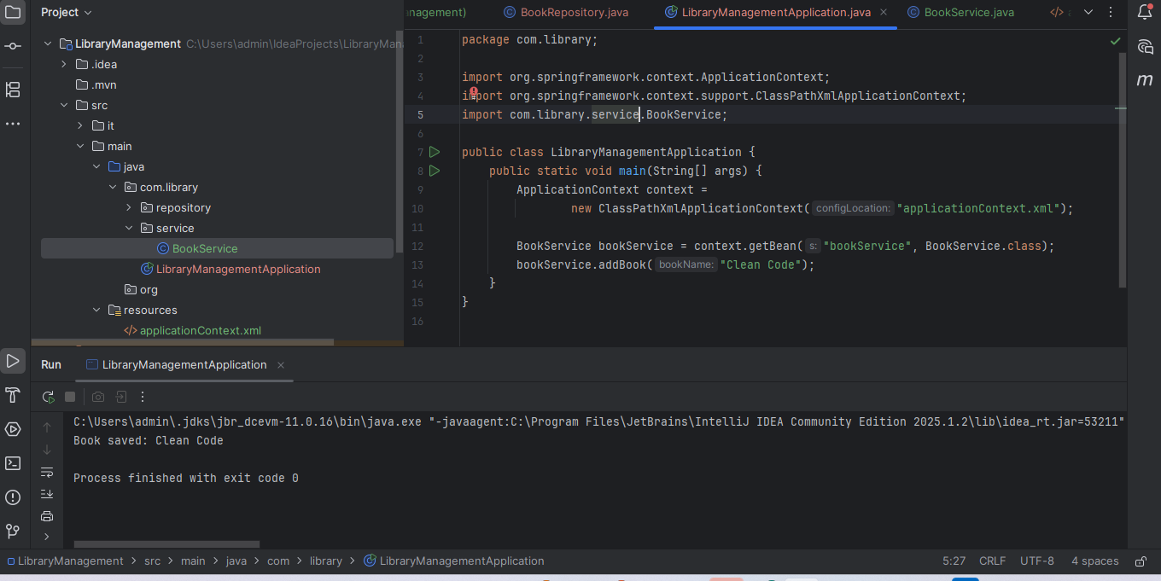

Exercise 2: Implementing Dependency Injection

Code:

File: BookRepository.java

Location: src/main/java/com/library/repository/

package com.library.repository;

public class BookRepository {

public void saveBook(String bookName) {

System.out.println("Book saved: " + bookName);

}

}

File: BookService.java

package com.library.service;

import com.library.repository.BookRepository;

public class BookService {

private BookRepository bookRepository;

// Setter method for dependency injection

public void setBookRepository(BookRepository bookRepository) {

this.bookRepository = bookRepository;

}

public void addBook(String bookName) {

bookRepository.saveBook(bookName);

}

}

**LibraryManagementApplication.java**

package com.library;

import org.springframework.context.ApplicationContext;

import org.springframework.context.support.ClassPathXmlApplicationContext;

import com.library.service.BookService;

public class LibraryManagementApplication {

public static void main(String[] args) {

ApplicationContext context =

new ClassPathXmlApplicationContext("applicationContext.xml");

BookService bookService = context.getBean("bookService", BookService.class);

bookService.addBook("Clean Code");

}

}

**applicationContext.xml**

<?xml version="1.0" encoding="UTF-8"?>

<beans xmlns="http://www.springframework.org/schema/beans"

xmlns:xsi="http://www.w3.org/2001/XMLSchema-instance"

xsi:schemaLocation="

http://www.springframework.org/schema/beans

http://www.springframework.org/schema/beans/spring-beans.xsd">

<!-- Repository Bean -->

<bean id="bookRepository" class="com.library.repository.BookRepository" />

<!-- Service Bean with Setter Injection -->

<bean id="bookService" class="com.library.service.BookService">

<property name="bookRepository" ref="bookRepository" />

</bean>

</beans>

Output:

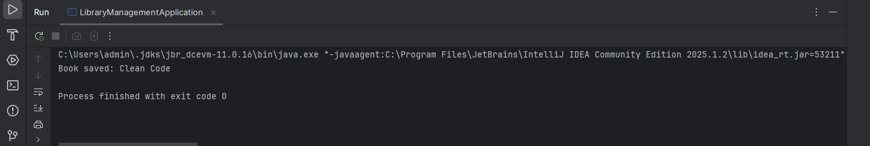

**Exercise 4: Creating and Configuring a Maven Project**

Code:

1.Add the following dependencies if not already added:

<!-- Spring AOP (for future AOP exercises) -->

<dependency>

<groupId>org.springframework</groupId>

<artifactId>spring-aop</artifactId>

<version>${spring.version}</version>

</dependency>

<!-- Spring WebMVC (for future web-based components) -->

<dependency>

<groupId>org.springframework</groupId>

<artifactId>spring-webmvc</artifactId>

<version>${spring.version}</version>

</dependency>

2.Make sure they go inside the <dependencies> section.

3: Ensure the Maven Compiler Plugin is present in your <build> section:

<build>

<plugins>

<!-- Compiler Plugin to set Java version -->

<plugin>

<groupId>org.apache.maven.plugins</groupId>

<artifactId>maven-compiler-plugin</artifactId>

<version>3.8.1</version>

<configuration>

<source>${maven.compiler.source}</source>

<target>${maven.compiler.target}</target>

</configuration>

</plugin>

</plugins>

</build>

Output:

